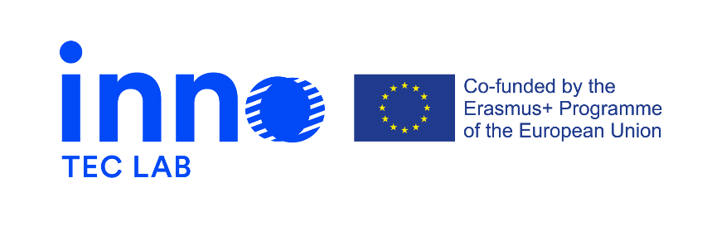

**Press release 3, March 2022**

**Erasmus + project -** Development of opportunities in the field of design for technical careers through innovation-laboratories – INNO-TEC-LAB

The project is a 24-month initiative that started on the 14th of September 2020.

Several outputs have been created during the last 6 months of the project:

The 1st and the 2nd session of Train-the-Trainers - structured online training for teachers has been created and led. Target groups that were involved in the training were staff members of the consortium and rectors, professors, teachers, trainers involved.

The participants met learners met for 4 live sessions:

1. Introduction

2. Circular coaching

3. New technologies: opportunities and challenges within education

4. Innovation and 21st century skills

The participants also got involved in a project work's development. Self-study and assignments' achievement was required to participants.

The Train-the-Trainers is available on a free online platform. Selected participants were registered on the platform to access the training.

Project partners have also started planning INNO-TEC-LAB courses for students. The courses will be developed and held from 9 of March until the end of May 2022. After a pilot edition, a second one will be held by the Higher Education Institutions involved in the project. Target groups involved are principally the technical career students, consequently the staff members of the consortium and rectors, professors, teachers, trainers and academic staff. The courses are aiming to implement the learning module developed at the beginning of the project. They will be based on encouraging and moderating the spaces of communication and debate, supporting active and quick interaction between participants and teachers. Main topics are: “Global challenges: sustainability as a common language”, “Soft skills and personal branding” and “Future Trends” Activities and learning progress will be monitored and controlled by the students themselves.

Planning of Multiplier event and 3rd Transnational project meeting

7th and 8th of April 2022, Helsinki, Finland

The aims are:

* Sharing intellectual outputs and results to date
* Creating an interactive event to reflect on how inter and transdisciplinarity can innovate careers and respond to the complexities of the evolving world.
* Involve the project’s target groups and involve stakeholders in an informative and active debate.

More project related news you can find on:

<https://www.innoteclab.eu/> and <https://www.facebook.com/InnoTecLab>