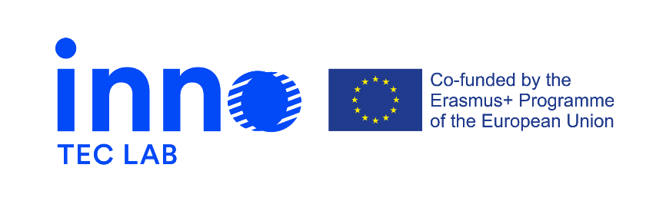

Press release 5, September 2022

Erasmus + project - Development of opportunities in the field of design for technical careers through innovation-laboratories – INNO-TEC-LAB
The project is a 24-month initiative that started on the 14th of September 2020.

Multiplier Event in Italy hosted by IED
The last INNO-TEC-LAB Multiplier Event was held on the 8th of September at ADI Museum in Milan, Italy. It was a hybrid event aimed at sharing and building on the project results with local and international stakeholders. The event consisted of two cross-sectorial panels on the following topics: “Innovation through the evolution of the relationship between design and technology” and “Systemic transformations for sustainable innovation – from inter-to-transdisciplinarity”
The speakers can be found below:
M.Campione Educational policies expert,
A.Gariboldi, President at Fondazione Fitzcarraldo
Clelia Bergna, Group Career Service Manager at IED
M. Castán Cabrero, Researcher, Educator and Creative Professional
B. Revelli, Head of Programmes at ELIA
M.Aakesson, Product Designer, Executive board member ADI
M.Thomson, Design strategist, Design Connect Founder and Director
S.Dimopoulos, European Programmes Manager at Microkosmos
In the afternoon students from IED UX master course and partners took part in a hands-on workshop addressing the challenges and opportunities of innovation from the perspectives of design and technology, sustainable education and learning, inter and transdisciplinary approaches.
The Multiplier Event was followed by a Transnational Project Meeting, during which weaknesses and strengths of the event were discussed in addition to addressing the project results in general and reflecting on the project.

Final results
Learning module, online “train-the-trainers”, INNO-TEC-LAB courses for students, platform of innovation laboratories were created during the duration of the project.
Access to the learning module, the INNO-TEC-LAB guidelines for online “train-the-trainers” and guidelines for trainers for student courses is available on INNO-TEC-LAB website.
A demo of how to use the platform is also available on the website.

More project related news you can find on:
https://www.innoteclab.eu/ and https://www.facebook.com/InnoTecLab

