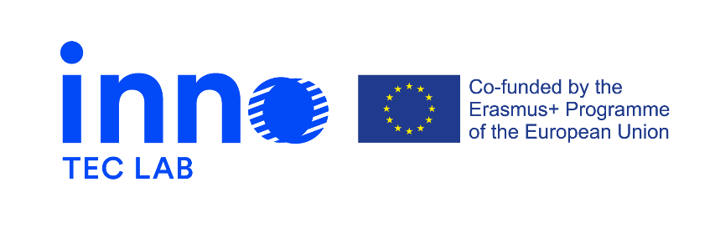

Press release 4, August 2022

Erasmus + project - Development of opportunities in the field of design for technical careers through innovation-laboratories – INNO-TEC-LAB
The project is a 24-month initiative that started on the 14th of September 2020.

The last months of implementing INNO-TEC-LAB

The last six months were the final months of the project INNO-TEC-LAB. During this period final steps were made at implementing created outputs.
Learning module
The learning module establishes the general guidelines for the acquisition of new knowledge and practical experience through a pedagogical approach.
The main goal of this learning module is to serve as a foundation for the courses that instructors are attending (train-the-trainers) and delivering.

Online “train-the-trainers”
Train-the-trainers - structured online training for teachers, is aiming to help teachers create high-quality online courses and virtual learning environments. Train-the-trainers addresses the changing role of teachers and teaching practices, covering topics such as new technologies, 21st century skills, and inclusivity. After this training, teachers can redesign an existing course or create a new one.
INNO-TEC-LAB courses for students

The student courses are a part of a bigger learning module focusing on innovation in technical education.
The course focuses on the topic of professional development and personal branding. It consists of 3 short units with some self-study and mentoring by the trainer. At the end of the course, students create a final project work, consisting of a personal pitch that shows their identity as a professional and reflects on the future of their field of work.
Platform of innovation laboratories

The platform was born as a shared working space in which to interact, exchange knowledge, generate content within the project and for future use. During the project’s implementation the platform hosted a synchronous online train-the-trainers program involving teachers, trainers and researchers from different HEIs and VET organizations. It also provided a dedicated space for the student courses, providing the opportunity to attend live sessions, interact across-institutions, gain access to useful additional resources.

Multiplier event in Italy hosted by IED
The last INNO-TEC-LAB multiplier event is going to be held on the 8th of September at the ADI Museum in Milan, Italy. It is a hybrid event aimed at sharing and building on the project results with local and international stakeholders.
Two cross-sectorial panels and the hands-on workshop is going to address the challenges and opportunities of innovation from the perspectives of design and technology, sustainable education and learning, inter and transdisciplinary approaches.

More project related news you can find on:
https://www.innoteclab.eu/ and https://www.facebook.com/InnoTecLab

