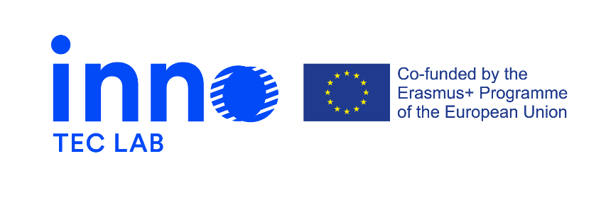

Press release 1, February 2021

Erasmus + project - Development of opportunities in the field of design for technical careers through innovation-laboratories – INNO-TEC-LAB
The project is a Strategic Partnership for Higher Education, co-financed by the Erasmus+ program of the European Union (Key Action 2). It’s aim is to create and validate a model based on interdisciplinarity and student-centered learning to support innovation through a network of innovation laboratories that will serve to improve learning tools, knowledge exchange, training of learners and researchers.
INNO-TEC-LAB is aimed primarily at teachers, researchers, lecturers and staff of partner organizations and students of technical careers, as well as public authorities, policymakers and the business sector. Moreover, the project involves 7 entities from different fields (universities, non-profit associations specializing in education, training entities) from 6 different countries in Europe – Istituto Europeo di Design (Italy), VSL Socialiniu inovaciju centras (Lithuania), Media Dizjan (Poland), European Digital Learning Network (Italy), SDMI - Sustainable Development Management Institute (France), Amsterdam University of Applied Science (Netherland) and Metropolia University of Applied Science (Finland).
With a duration of 24 months starting September 2020 INNO-TEC-LAB is going to create and validate an interdisciplinary model to support innovation in the field of design in technical careers through a network of inovation laborotories; to initiate the creation of transdisciplinary framework across careers, leveraging on the diversity in knowledge and practice of the partner institutions and to develop a digital platform to connect the innovation labs and facilitate knowledge generation and exchange.
The project will be told through the website and on the social networks of the project and of the partners. More project related information you can find on www.socin.lt and https://www.facebook.com/InnoTecLab.

