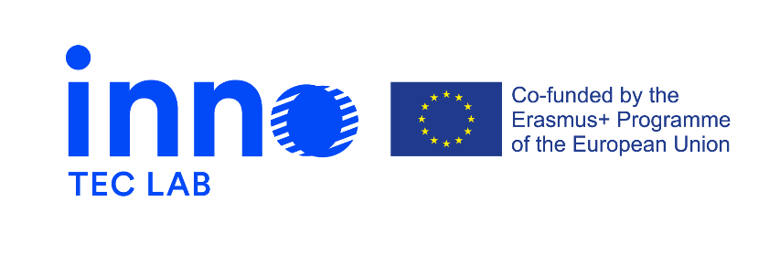

Press release 2, September 2021

Erasmus + project - Development of opportunities in the field of design for technical careers through innovation-laboratories – INNO-TEC-LAB
The project is a 24-month initiative that started on the 14th of September 2020.

In addition to its own Facebook page there’s now a website specially dedicated to the project.
There also has been a several intellectual outputs created. One of them – learning module. The main objective of the learning module is to serve as the basis for the courses that the trainers will attend (TRAIN-THE-TRAINERS) and will implement (INNO-TEC-LAB courses). The learning module created includes the objectives, the scope of learning outcomes, activities and their respective materials, methodology and resources required. Design of a special section on activities aimed at improving the active participation of female learners and of participants with fewer opportunities due to social, economic obstacles.
Another intellectual output - Train-the-Trainers - a structured online training for teachers. Its main goal is to strengthen the capacity of teachers, and in turn that of their relevant institutions, to respond to and anticipate the changing in educational and working environment as specifically related to the technical careers, in accordance with sustainability and context-specific environments.
The target groups involved are the staff of members of the consortium, rectors, professors, teachers, trainers involved.
Train-the-Trainers is available on a free online platform. Selected participants only need to register on the platform to access the training. The first session (pilot) is open for participant from 21/9/21 to 14/10/21 for a total number of hours of 24. A second session will be implemented by the end of the year.

More project related news you can find on:
https://www.innoteclab.eu/ and https://www.facebook.com/InnoTecLab

